

SUPERIOR UNIVERSITY LAHORE
GOLD CAMPUS

NAME: MUHAMMAD MOIZ RAZA
ROLL NO: SU92-BSAIM-F24-061
PROGRAM: ARTIFICIAL INTELLIGENCE
SEMESTER: 4th SEMESTER
SECTION: BSAI-4A
SUBJECT: PROGRAMMING OF AI (LAB)

Submission Title: LAB TASK 6
Submitted To: Sir Rasikh Ali

TITLE: Automatic Object Detected

OVERVIEW:
This project is designed to detect vehicles and other objects using yolov8. it works on images, videos, folders, and live webcam feeds. a simple gui allows users to preview, adjust settings, and save results, making it useful for traffic monitoring, surveillance, and learning computer vision concepts.

Working
The system loads a pretrained detection model to identify objects in media. it draws bounding boxes with labels and supports real-time video feeds. users can adjust detection thresholds, control processing speed, and preview results before saving. optimization for gpu/cpu ensures faster performance even with multiple objects.

Features
- detects vehicles or all coco objects
- supports images, videos, folders, and live webcam feeds
- annotated outputs with bounding boxes and labels
- gui for preview, threshold adjustment, speed control, and saving results
- programmatic access for integration into custom applications

Uses
- traffic monitoring – detect and count vehicles in real time
- surveillance – track moving objects in videos or live feeds
- object tracking – automated analysis in videos or camera feeds
- learning & experimentation – understand computer vision, yolov8, and gui integration
- project integration – embed detection in custom applications or research projects

Real-Life Applications
- Smart Traffic Systems – monitor traffic flow, detect congestion, and manage traffic signals automatically
- Parking Management – detect empty/occupied parking spaces
- Security Surveillance – identify suspicious or unauthorized objects in public spaces
- Autonomous Vehicles – help self-driving cars detect pedestrians, vehicles, and obstacles
- Industrial Automation – monitor production lines, detect defects or moving objects

Technology
- Python – main programming language
- Ultralytics YOLOv8 – object detection engine
- PyTorch – model backend for gpu/cpu
- OpenCV (cv2) – handles images, videos, and drawing bounding boxes
- Tkinter & Pillow – build gui and display images
- tkinter.ttk – progress bars, scrollbars, and sliders in gui
- Standard Python Libraries – pathlib, os, sys, threading, etc.

Screenshot:
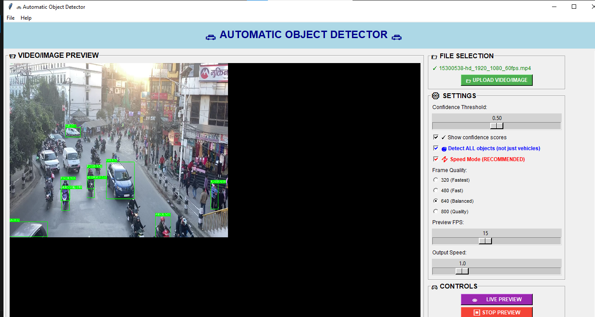

THE END

